**Project Report**

Joe Selshia: 711120243021

Korrapati Anusha: 711120243028

Malli Chandini:711120243031

Valluru Rishitha: 711120243055

**Introduction:**

* 1. **Overview:**

Building a website using Canva is a user-friendly and creative process that leverages Canva's design tools and templates to create a visually appealing and functional website. Canva, primarily known for its graphic design capabilities, now offers a feature called Canva Websites, which simplifies website creation for users without extensive coding or design skills. Users can choose from a variety of professionally designed templates, customize them with their own content, images, and branding elements, and publish their website with ease. Canva Websites provides a convenient drag-and-drop interface, making it accessible to beginners and small businesses looking to establish an online presence quickly and affordably.

* 1. **Purpose:**

The purpose of our project to build a website using Canva is to create a professional-looking and easy-to-manage website without any coding experience. Canva is a popular graphic design platform that offers a variety of templates and design elements that make it easy to create a website that is both visually appealing and informative.

**Problem Definition and Design Thinking:**

**2.1 Empathy Map:**

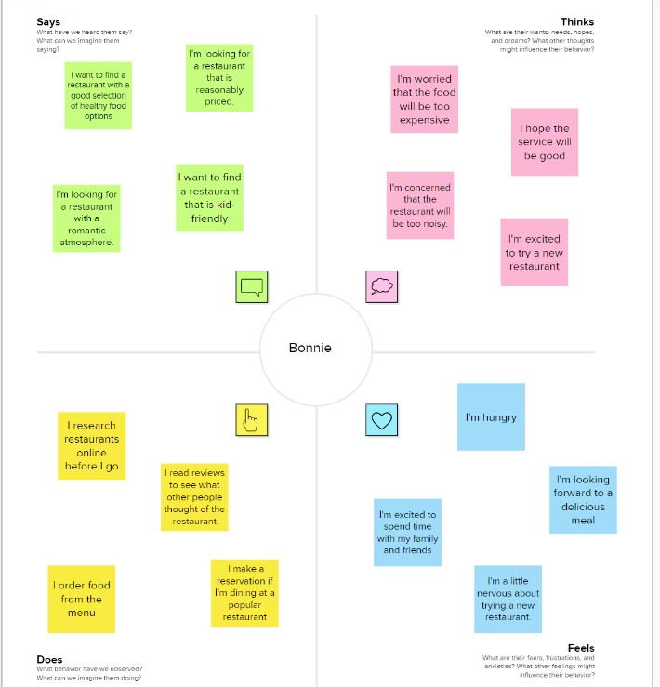

**2.2 Ideation and Brainstorming:**



**3. Result**

The website called **The Sunday Bite** is created using canva. Below are the webpages from the website:

**Main Landing page**

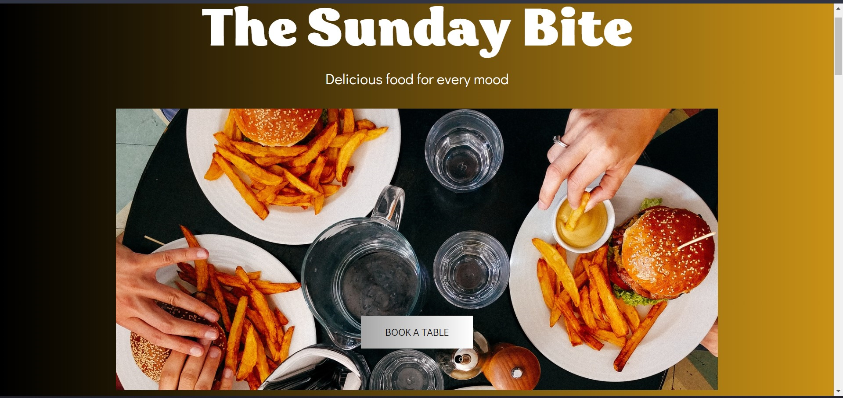

**About us**

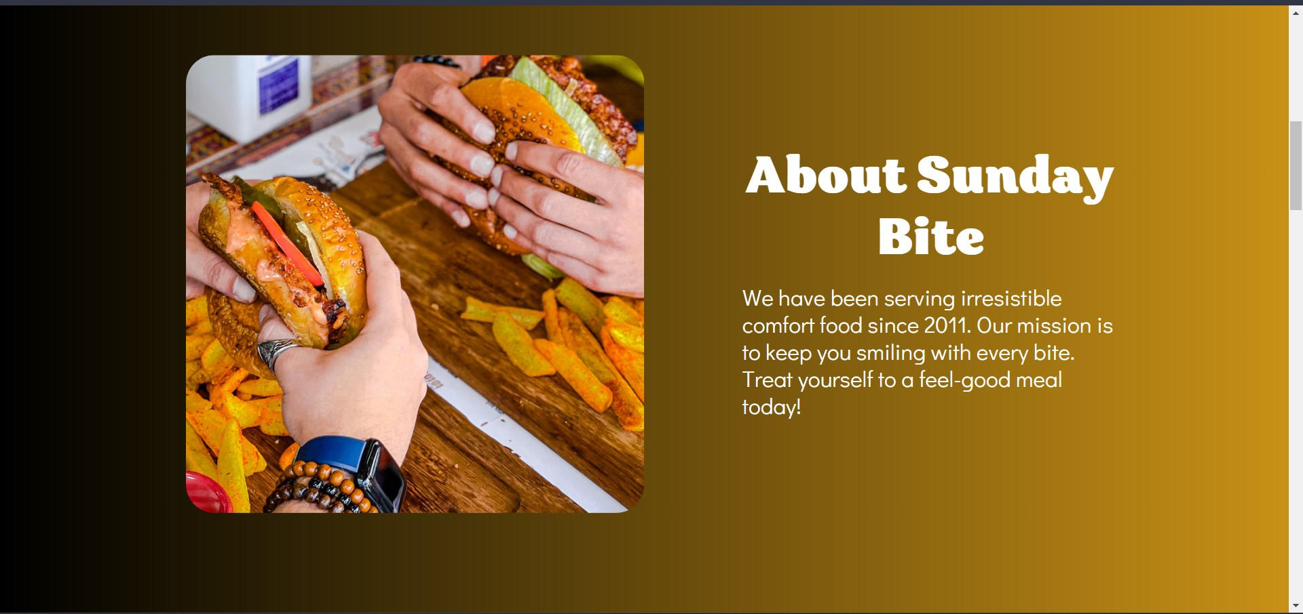

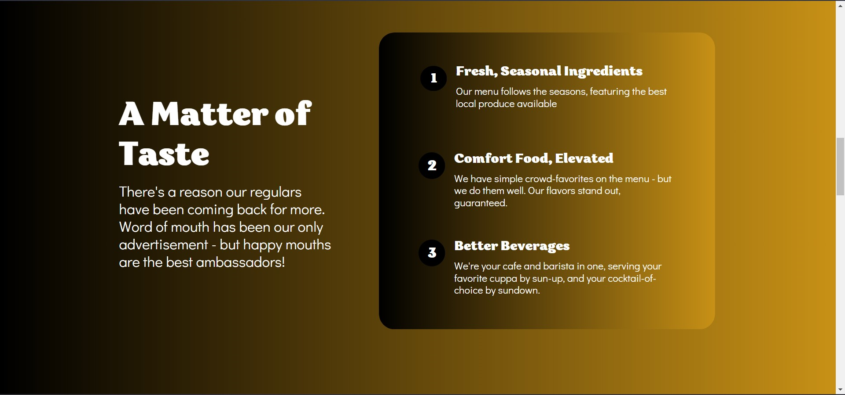

**Popular Food**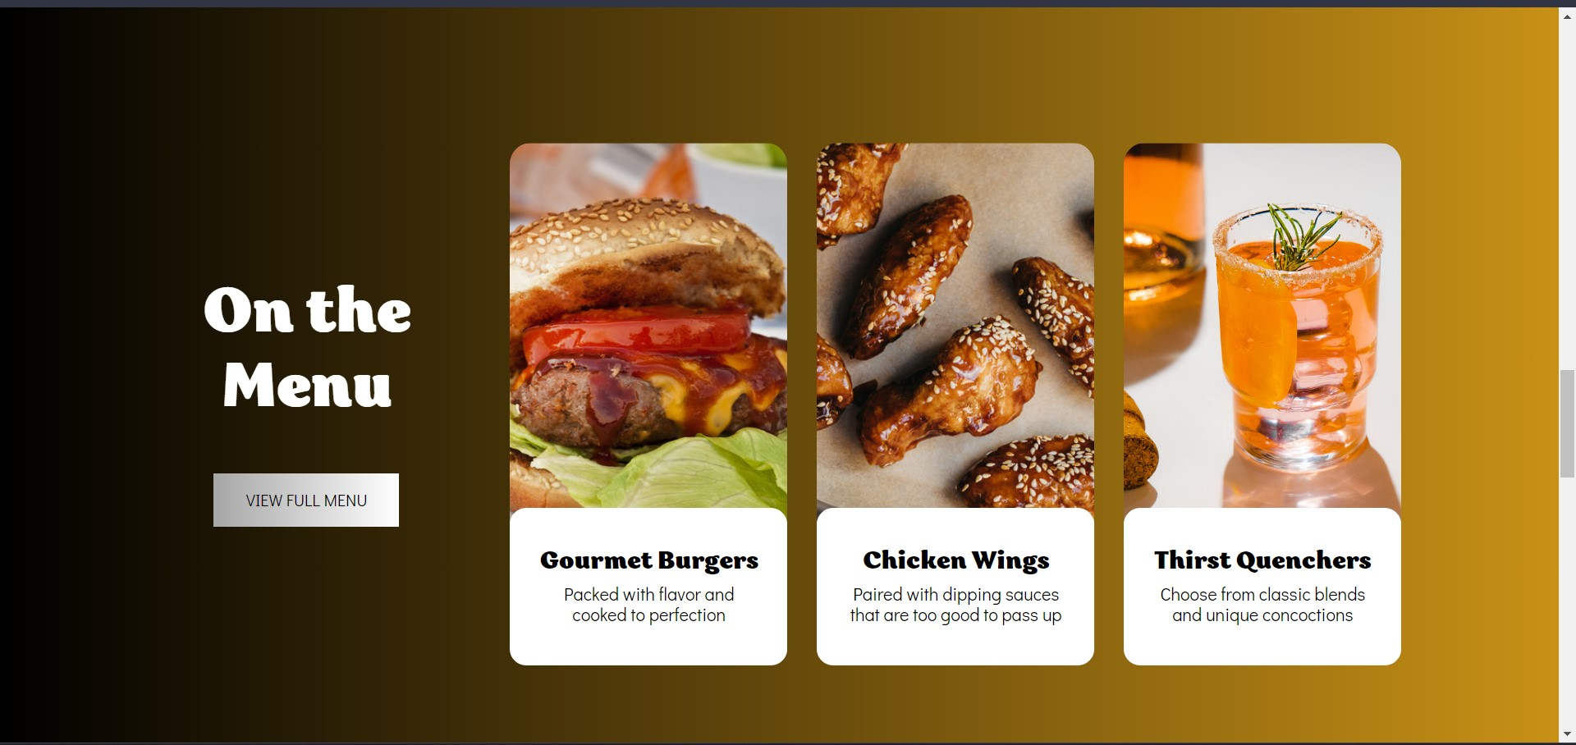

**Our Community**

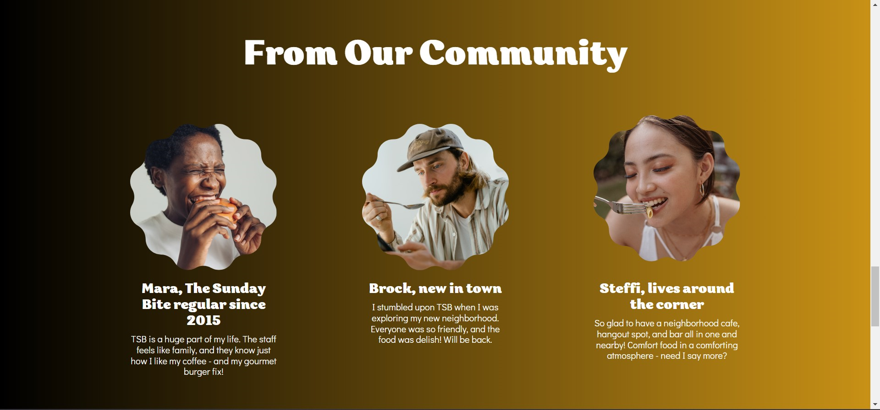



**4. Advantages:**

* **Increased visibility and reach.** A website can help to increase the visibility and reach of your restaurant, making it easier for potential customers to find us.
* **More information for customers.** Our website can provide customers with more information about our restaurant, including its menu, location, hours of operation, and contact information.
* **Improved customer engagement.** This website can help to improve customer engagement by providing customers with a way to interact with your restaurant online. For example, customers can leave reviews, sign up for your email list, or make reservations through the website.
* **Increased sales.** Creating a website can help to increase sales by providing customers with a convenient way to order food online. Customers can also use your website to purchase gift cards or merchandise.

**Disadvantages:**

* **Cost of development and maintenance.** Creating and maintaining a website can be costly, especially if you hire a web developer to do the work for you.
* **Time commitment**. Creating and maintaining a website requires a time commitment. You will need to regularly update your website with new information and content.
* **Competition from other restaurants.** There are many other restaurants that have websites, so you will need to find a way to make your website stand out from the competition.

**5. Applications**

Product Showcase

E-commerce Platform

Subscription Service

Food Blog

Customer Reviews and Testimonials

Social Media Integration

**6. Conclusion**:

In conclusion, a well-designed western food and beverage website can be a powerful asset for our food business. It serves as a digital storefront, a platform for engagement, and a means to showcase your gourmet dishes and brand identity. By carefully considering the applications and features mentioned earlier, we can create a website that not only attracts food enthusiasts but also converts visitors into loyal customers. It provides a convenient and engaging way for customers to explore your food offerings, learn about the brand, and make online purchases or subscriptions. With the right content, e-commerce capabilities, and user experience, your brand website can become a central hub for connecting with your audience, building brand loyalty, and driving the success of your coffee business in the digital age.